Chapter 16, Solution 15.

For the circuit in Fig. 16.38, calculate the value of R needed to have a critically damped response.

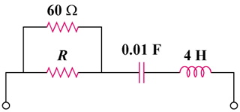

Figure 16.38
For Prob. 16.15.
8.13
Solution

Step 1. Let R||60 = R_{o}. Next, convert the circuit into the s-domain and solve for T(s) = R_{o} + [1/(0.01s)] + 4s = R_{o} + (100/s) + 4s =
[(4s²+R_{o}s+100)/s]. Now to solve for the roots that represent a critically damped system.

s_{1,2} = {-R_{o}±[(R_{o})²-4(400)]^{0.5}}/2.

The system is critically damped when [(R_{o})²-4(400)] = 0.

Step 2. (R_{o})² = 1600 or R_{o} = 40. Since R_{o} = [Rx60/(R+60)] = 40 or
60R = 40R+2400 or 20R = 2400 or R = 120 Ω.

